Assignment-1
PROBLEM STATEMENT:
Create an account in AWS and configure a budget.
Solution:
Account Creation:
1.Sign up. Create a new AWS account.
2.Enter root user email address and AWS account name.
3.Verify your email address.
4.Set your password, then click on “Continue”. (Step 1 of 5)
5.Fill the required details, tick off the checkbox, and then click on “Continue”. (Step 2 of 5)
6.Complete payment for successful registration. (Step 3 of 5)
7.Verify phone number. (Step 4 of 5)
8.Select a Support plan. (Step 5 of 5)
9.Successful account creation.
Budget Configuration:
1.Log in to AWS console, go to your username and there click on ‘Billing and Cost Management’.

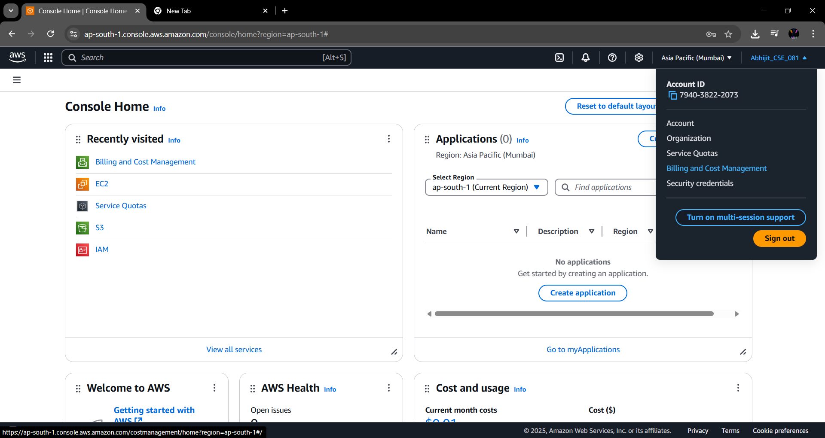

2.Under ‘Budgets and Planning’, click on ‘Budgets’ and create budget.
Configure budget setup by clicking on “Customize (advanced)” then click on next.
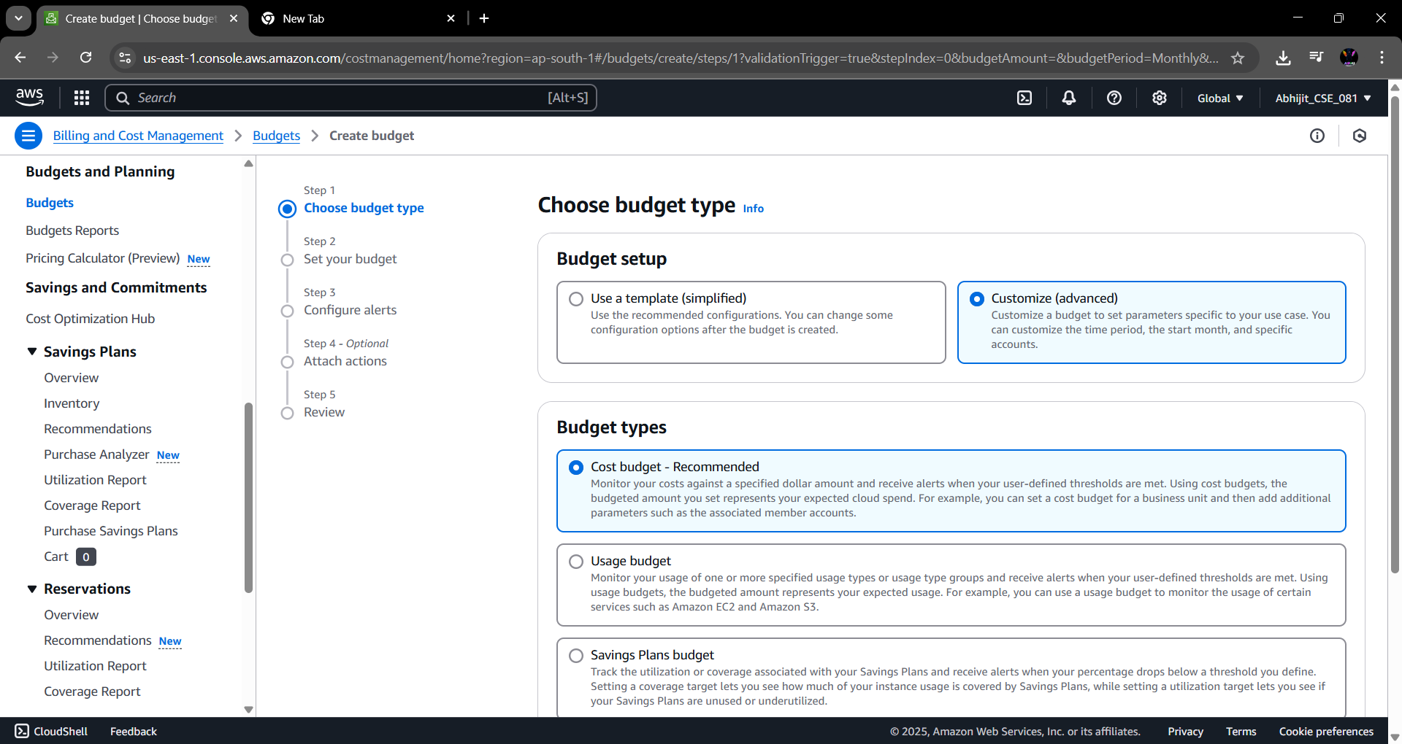
3.Add budget details. (Name, period, amount, etc)
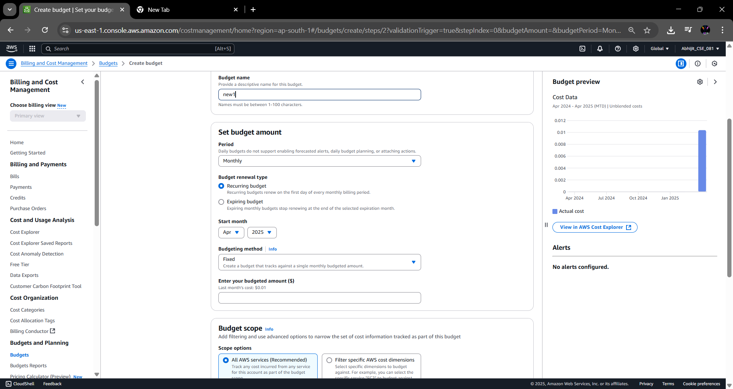
4.Create Alert Threshold.
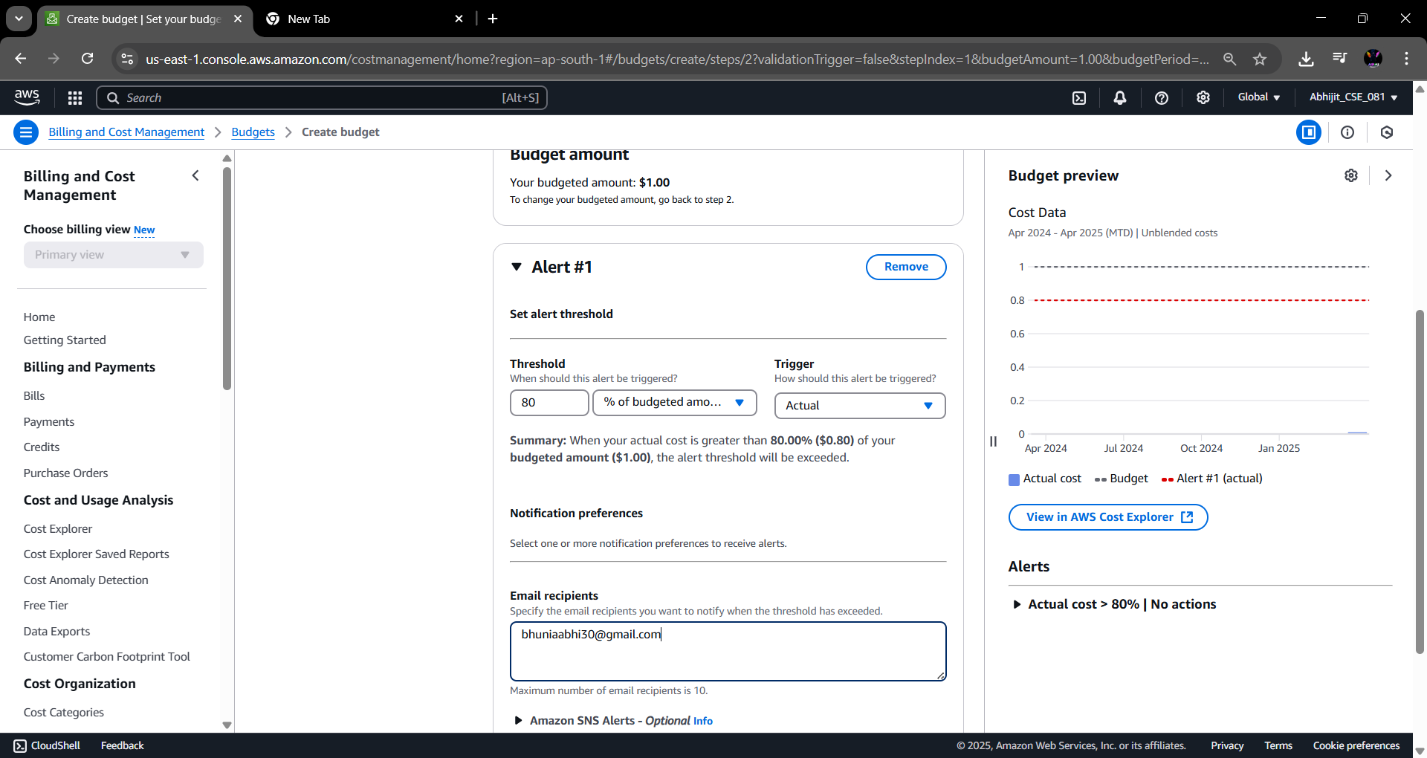

5.After clicking on add threshold, we fill-in necessary details and then click on “Next”.
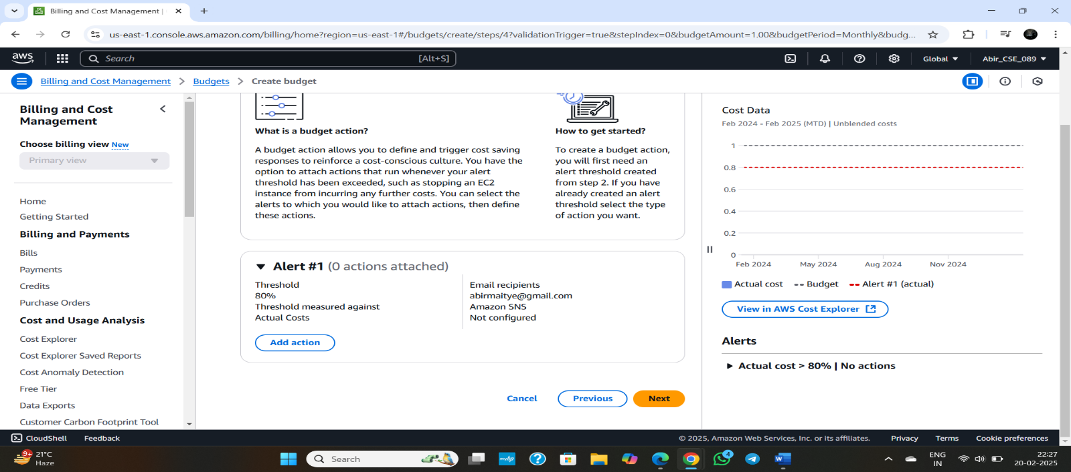
We review our budget and click on “Create Budget”.
6.Budget is successfully created.
